AIM
To apply K-Means Clustering and Hierarchical Clustering on a dataset and analyze how data points are grouped into clusters based on similarity.

THEORY
Clustering
Clustering is an unsupervised learning technique used to group similar data points together without predefined labels.

K-Means Clustering
- Divides data into K clusters
- Each cluster has a centroid (center)
- Algorithm:
  - Choose K
  - Assign points to nearest centroid
  - Update centroids
  - Repeat until stable
Works well for large datasets
Hierarchical Clustering
- Builds a tree-like structure (dendrogram)
- Two types:
  - Agglomerative (bottom-up)
  - Divisive (top-down)
No need to specify clusters initially

PROCEDURE
- Import libraries
- Load dataset
- Select features
- Apply K-Means
- Apply Hierarchical Clustering
- Visualize clusters
- Interpret results
CODE:
# ====================================================
# K-MEANS & HIERARCHICAL CLUSTERING (FIXED CODE)
# ====================================================

# -------- IMPORT LIBRARIES --------
import pandas as pd
import matplotlib.pyplot as plt

from sklearn.cluster import KMeans
from sklearn.preprocessing import StandardScaler
from scipy.cluster.hierarchy import dendrogram, linkage

# -------- LOAD DATASET --------
data = pd.read_csv("Mall_Customers.csv")

print("Original Data:\n", data.head())

# -------- HANDLE CATEGORICAL DATA --------
# Convert text (Male/Female etc.) to numeric
data = pd.get_dummies(data)

print("\nAfter Encoding:\n", data.head())

# -------- FEATURES --------
X = data

# -------- SCALING --------
scaler = StandardScaler()
X_scaled = scaler.fit_transform(X)

# ====================================================
# K-MEANS CLUSTERING
# ====================================================
kmeans = KMeans(n_clusters=3, random_state=42)
kmeans_labels = kmeans.fit_predict(X_scaled)

# Add cluster column
data['Cluster'] = kmeans_labels

print("\nK-Means Clusters Added:\n", data.head())

# -------- PLOT --------
plt.figure()
plt.scatter(X_scaled[:, 0], X_scaled[:, 1], c=kmeans_labels)
plt.title("K-Means Clustering")
plt.xlabel("Feature 1")
plt.ylabel("Feature 2")
plt.show()

# ====================================================
# HIERARCHICAL CLUSTERING
# ====================================================
linked = linkage(X_scaled, method='ward')

plt.figure()
dendrogram(linked)
plt.title("Hierarchical Clustering")
plt.xlabel("Data Points")
plt.ylabel("Distance")
plt.show()

OUTPUT:

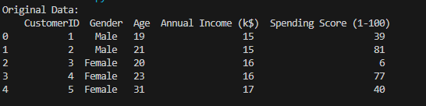
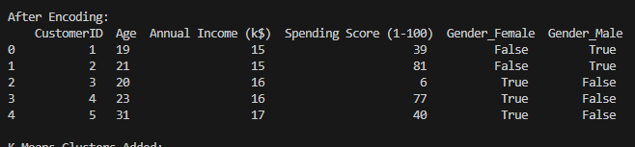
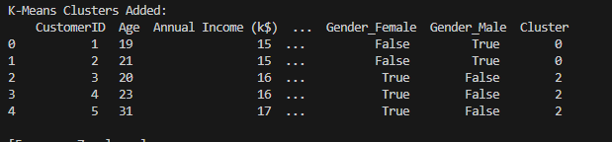

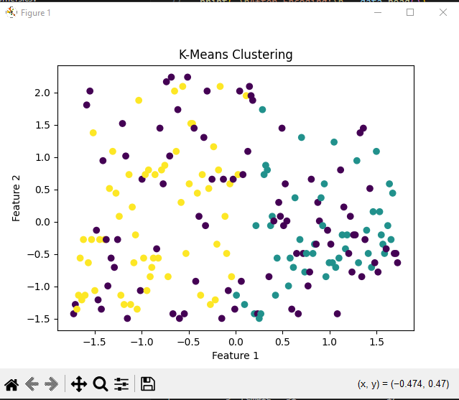
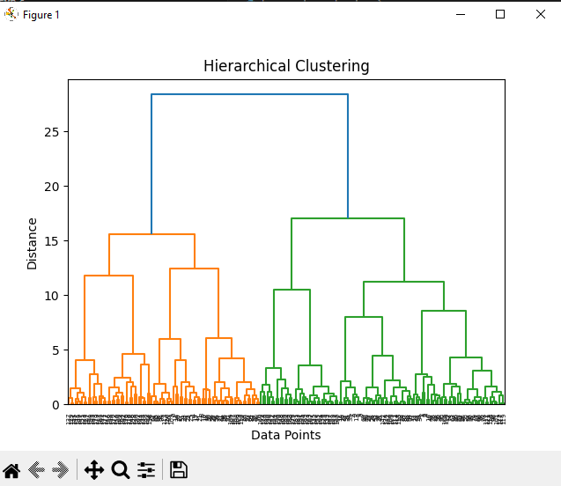

CONCLUSION:
- K-Means efficiently groups data into fixed clusters
- Hierarchical clustering shows relationships between clusters
- Both methods help in pattern discovery without labels
- Useful in:
  - Customer segmentation
  - Image compression
  - Market analysis

